**PROFESSIONAL PROFILE**

**AMANDA**

**BELL**

Start off with a sentence about yourself. Include something on your education and your career goals. The purpose is to show why you would be ideal for the job. Explain some of the important skills you have picked up in your career up to this point. Make sure that the skills that you mention are the ones that they looking for.

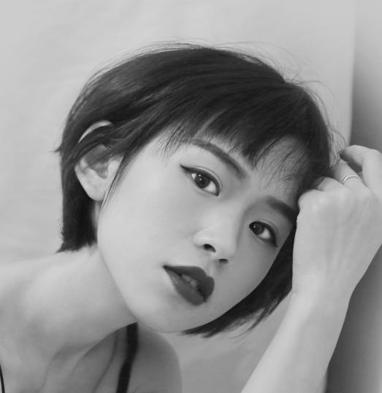

**WORK EXPERIENCE**

**ENTER JOB POTISION HERE**

Company/Location/Years

Type or Enter a brief summary of your responsibilities here, list of your duties/responsibilities:

* Creation and distribution of press releases.
* Developing strong and good relationships within the.
* Assisting with the development of media campaign strategy.
* Lorem ipsum dolor sit it mas amet, consectetuer adipiscing

**CONTACT**

location icon

Twitter.com/User name

YourEmail@domain.com

Address / City

phone icon

0123 – 345 - 678

message icon

connect, media, news, share, social, tweet, twitter icon

**ENTER JOB POTISION HERE**

Company/Location/Years

Type or Enter a brief summary of your responsibilities here, list of your duties/responsibilities:

* Lorem ipsum dolor sit amet, mass elconsectetuer adipiscing
* Fusce posuere, magna sed pulvinar ultricies, purus.
* Fusce posuere, magna sed pulvinar ultricies, purus.

Your Degree Here

Harvard University

2010- Years

**EDUCATION**

Your Degree Here

Harvard University

2010- Years

MAC & PC System

Microsoft Excel

**SKILLS**

Adobe Photoshop

Microsoft Word

Corel Draw

**ENTER JOB POTISION HERE**

Company/Location/Years

Type or Enter a brief summary of your responsibilities here, list of your duties/responsibilities:

* Lorem ipsum dolor sit amet, mass elconsectetuer adipiscing
* Fusce posuere, magna sed pulvinar ultricies, purus.
* Fusce posuere, magna sed pulvinar ultricies, purus.

**ENTER JOB POTISION HERE**

Company/Location/Years

Type or Enter a brief summary of your responsibilities here, list of your duties/responsibilities:

* Lorem ipsum dolor sit amet, mass elconsectetuer adipiscing
* Fusce posuere, magna sed pulvinar ultricies, purus.
* Fusce posuere, magna sed pulvinar ultricies, purus.