

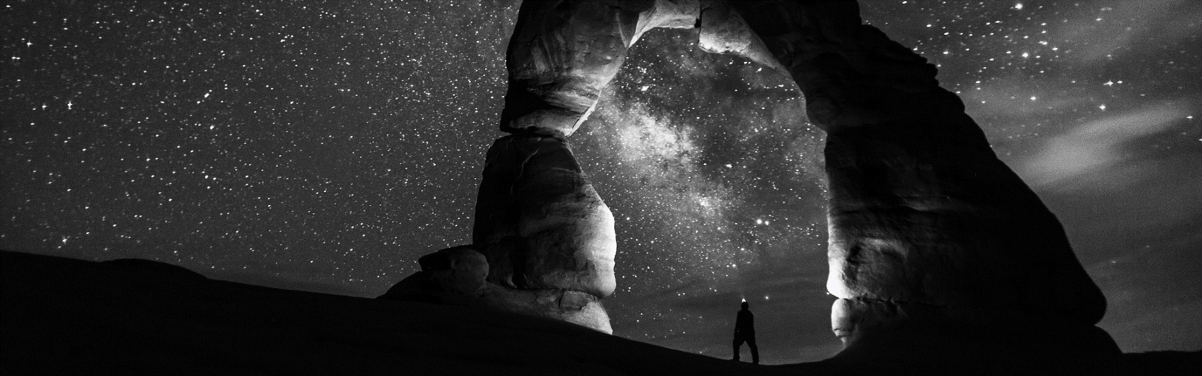

WEB DEVELOPER

**MICHALE JACKSON**

13500135000 Service@500d.me Guangzhou City, Guangdong Province



HEADING TEXT

Xxxxxxxxxxxxxxxxxxxxxxxxxxxxxxxxxxxxxxxxxxxxxxx

xxxxxxxxxxxxxxxxxxxxxxxxxxxxxxxxxxxxxxxxxxxxxxx

xxxxxxxxxxxxxxxxxxxxxxxxxxxxxxxxxxxxxxxxxxxxxxx

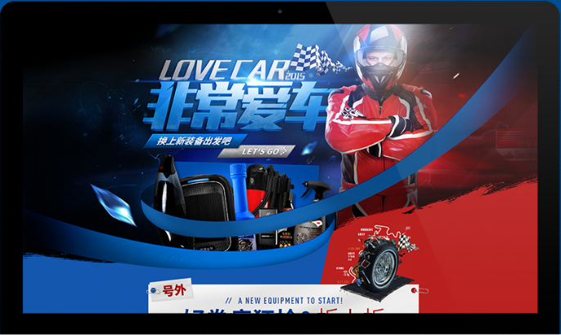

HEADING TEXT

Xxxxxxxxxxxxxxxxxxxxxxxxxxxxxxxxxxxxxxxxxxxxxxx

xxxxxxxxxxxxxxxxxxxxxxxxxxxxxxxxxxxxxxxxxxxxxxx

xxxxxxxxxxxxxxxxxxxxxxxxxxxxxxxxxxxxxxxxxxxxxxx

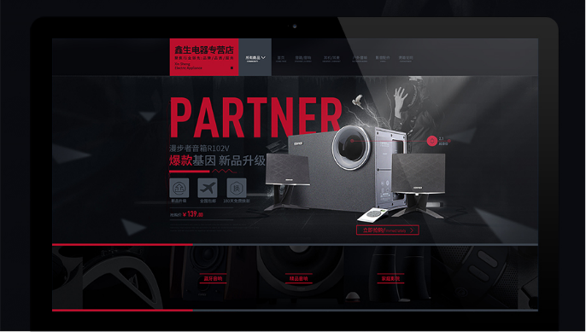

HEADING TEXT

Xxxxxxxxxxxxxxxxxxxxxxxxxxxxxxxxxxxxxxxxxxxxxxx

xxxxxxxxxxxxxxxxxxxxxxxxxxxxxxxxxxxxxxxxxxxxxxx

xxxxxxxxxxxxxxxxxxxxxxxxxxxxxxxxxxxxxxxxxxxxxxx