**PROFESSIONAL PHOTOGRAPHER**

**CAROLINE**

**DIAZ**

PROFESSIONAL PROFILE

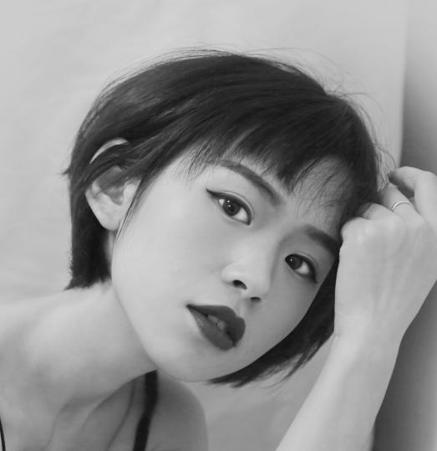

Start off with a sentence about yourself. Include something on your education and your career goals. The purpose is to show why you would be ideal for the job. Explain some of the important skills you have picked up in your career up to this point. Make sure that the skills that you mention are the ones that they looking for.

WORK EXPERIENCE

location iconphone iconmessage icon

CONTACT

YourEmail@domain.com

Address / City

0123 – 345 - 678

ENTER JOB POTISION HERE

Company/Location/Years

Type a brief summary of your responsibilities here, list of your duties/responsibilities. You want to tailor them for each job you apply for. Be specific when outlining your duties. Perhaps your list of duties will look something like this:

* Creation and distribution of press releases.
* Developing strong and good relationships within the.
* Assisting with the development of media campaign strategy.
* Lorem ipsum dolor sit it mas amet, consectetuer adipiscing elit Maecenas porttitor congue massa.

EDUCATION

Your Degree Here

Harvard University

2010- Years

Your Degree Here

Harvard University

2010- Years

ENTER JOB POTISION HERE

Company/Location/Years

Type a brief summary of your responsibilities here, list of your duties/responsibilities. You want to tailor them for each job you apply for. Be specific when outlining your duties. Perhaps your list of duties will look something like this:

* Lorem ipsum dolor sit amet, mass elconsectetuer adipiscing elit Maecenas porttitor congue massa lectus
* Fusce posuere, magna sed pulvinar ultricies, purus.
* Fusce posuere, magna sed pulvinar ultricies, purus.

MAC & PC System

Microsoft Excel

Adobe Photoshop

Microsoft Word

Corel Draw

SKILLS